|  |  |
| --- | --- |
| Name | Usama shafiq |
| Ag # | 2018-ag-1743 |
| Section | B |
| Github ID | usamashafiq819 |

**Assignment week 1**

**Question no 1:-**

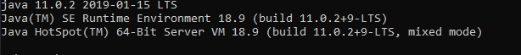

**Question no 2:-**

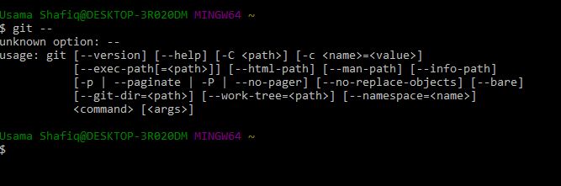

**Question no 3:-**

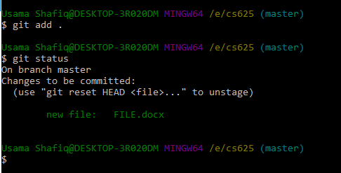

**Question no 4:-**

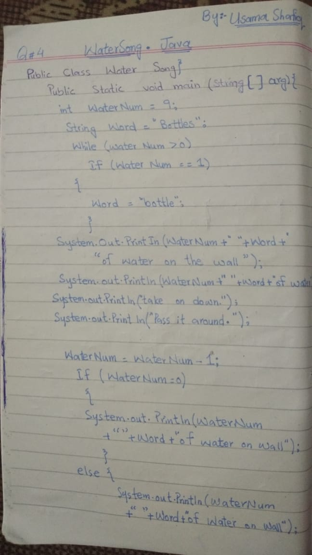

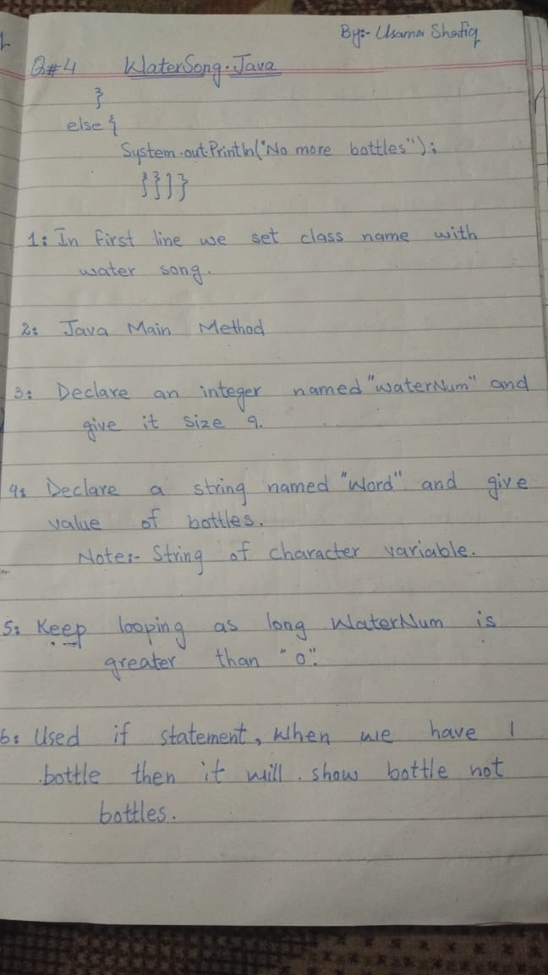

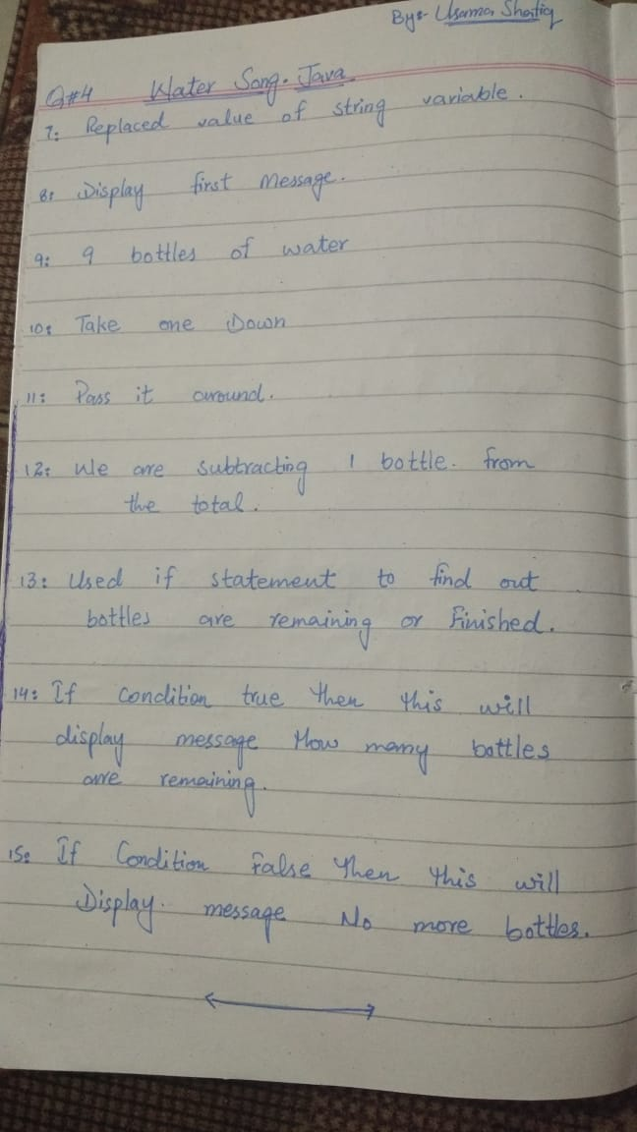

**Question no 5 :-**

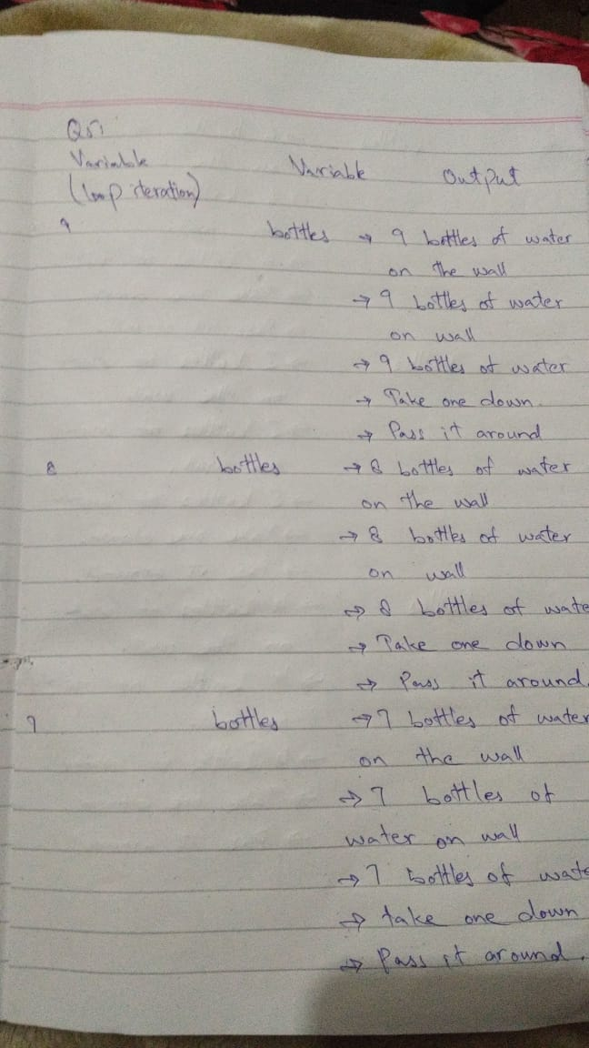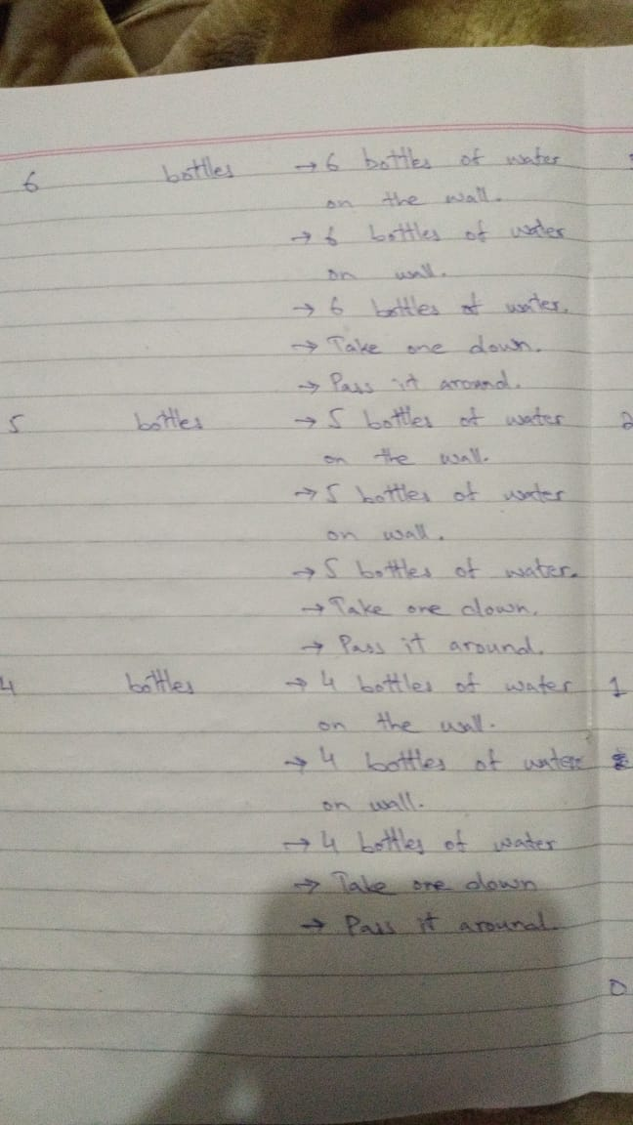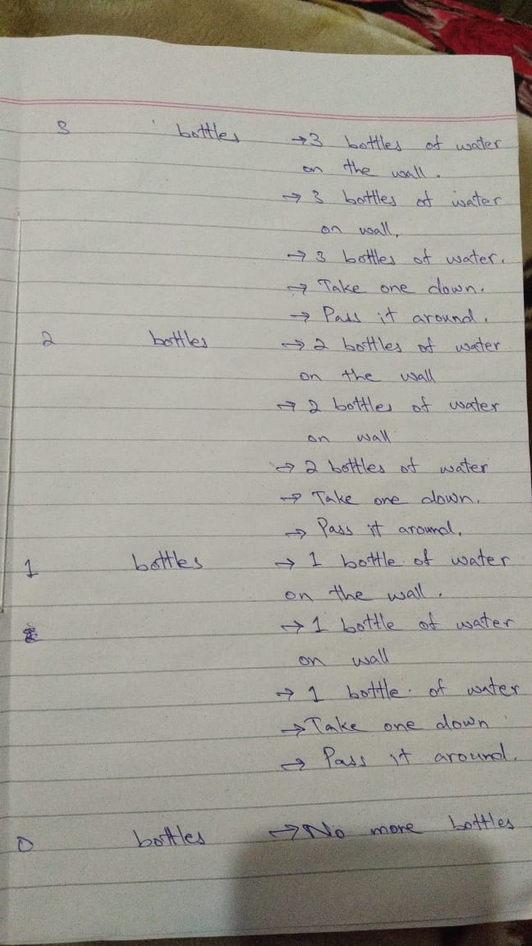

**Question no 7:-**

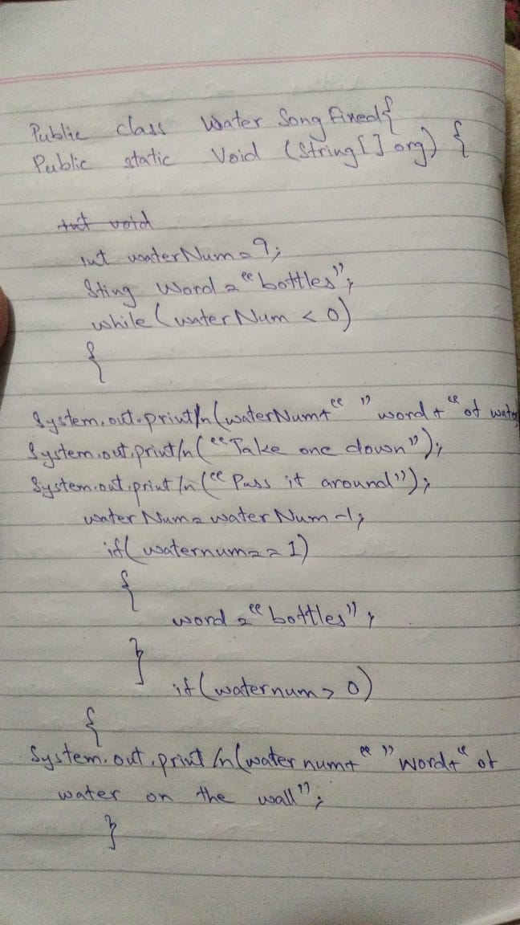

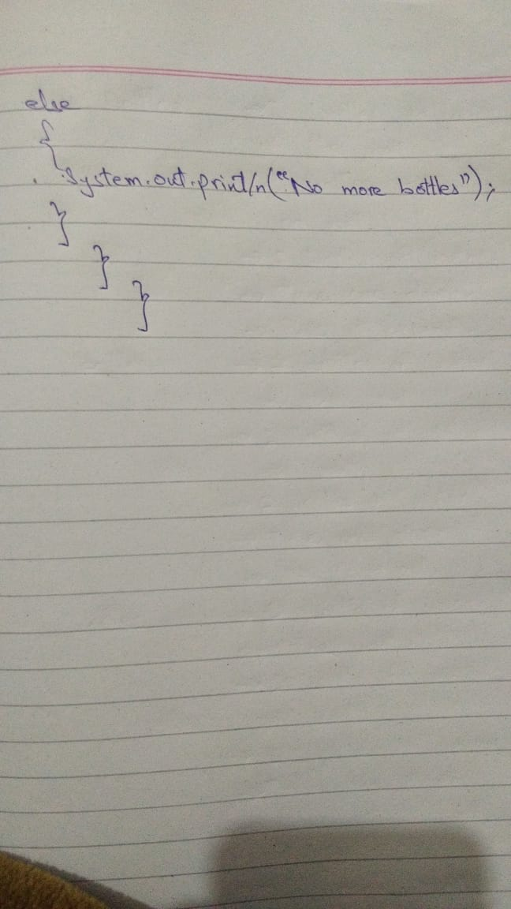

**Question no 9:-**

